

**A Project Report On**

# AUTOMATION TESTING ON TutorialsNinja WEBSITE

**By**

**Gayatri M Pejolli**

**Batch:(2021-5764)**

**Course: S Prayas Software Test Engineer**

**Under the Guidance of**

**Miss. Priyanka Desale**

**(Technical Trainer)**

**EduBridge**

## INTRODUCTION

This Project aims to do overall testing like functional testing, GUI testing on website to check quality of application. It helps to improve quality of website and saves time for manually doing this testing. In this project our main focus is to check functionalities available on website. Also, it includes title check and all links count with their working status.

## SOFTWARE REQUIREMENTS

* Operating System: Windows 10
* Browser: Latest version of Chrome
* IDE: Eclipse IDE
* Automation Tool: Selenium WebDriver
* Front-end: Java

### TC_01: Launch the browser and open New Demo Tour Website.

System.setProperty("webdriver.chrome.driver","D:\\selenium\\chromedriver_win32\\chromedriver.exe");

WebDriver w=new ChromeDriver();

### TC_02: Get URL

w.get("http://tutorialsninja.com/demo/");

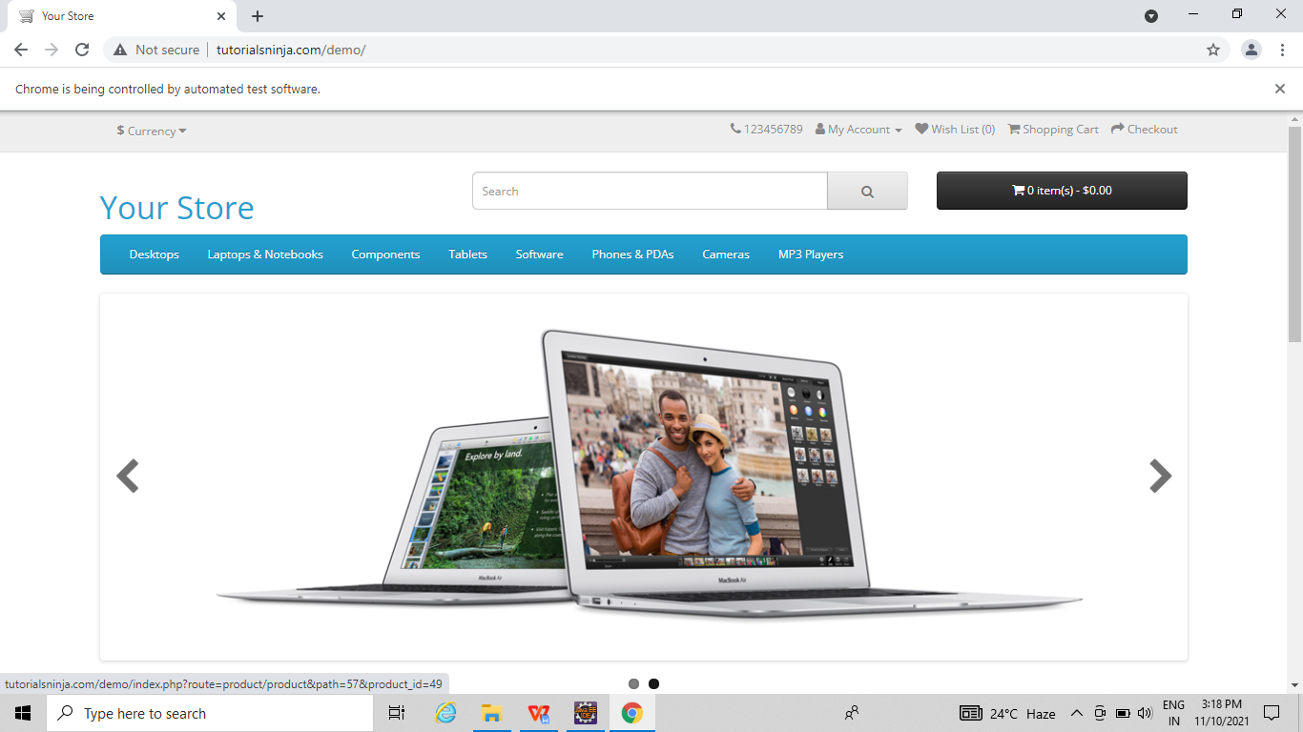

### TC_03: To Check DeskTops Option

w.findElement(By.linkText("Desktops")).click();

### 

### TC_04: To Check PC option

w.findElement(By.linkText("PC (0)")).click();

### TC_05:To Check the Continue Button

w.findElement(By.linkText("Continue")).click();

w.findElement(By.linkText("Desktops")).click();

### TC_06:To check the Mac option

w.findElement(By.linkText("Mac (1)")).click();

### TC_07:To Check the list logo

w.findElement(By.xpath("//body/div[@id='product-category']/div[1]/div[1]/div[1]/div[1]/div[1]/button[1]/i[1]")).click();

### TC_08:To Check the Grid logo

w.findElement(By.xpath("//body/div[@id='product-category']/div[1]/div[1]/div[1]/div[1]/div[1]/button[2]/i[1]")).click()

### TC_09:To check the sortBy and select option

w.findElement(By.id("input-sort")).click();

w.findElement(By.xpath("//option[contains(text(),'Name (A Z)')]")).click();

### TC_10:To check the show option and select option

w.findElement(By.id("input-limit")).click();

w.findElement(By.xpath("//option[contains(text(),'25')]")).click();

### TC_11:To check the iMAC option

w.findElement(By.linkText("iMac")).click();

w.findElement(By.id("input-quantity")).sendKeys("3");

### TC_12:To check the Add to Cart button

w.findElement(By.id("button-cart")).click();

### TC_13:To check the Review Section

w.findElement(By.linkText("Reviews (0)")).click();

w.findElement(By.name("name")).sendKeys("Dipali");

w.findElement(By.name("text")).sendKeys(" its good good good good good goodgood good good good good good good godd ");

w.findElement(By.name("rating")).click();

### TC_14:To check Continue Button

w.findElement(By.id("button-review")).click();

### TC_15:To check the Home logo

w.findElement(By.xpath("//body/div[@id='product-product']/ul[1]/li[1]/a[1]/i[1]")).click();

w.findElement(By.linkText("Desktops")).click();

### TC_16:To check the laptops and notebooks Option

w.findElement(By.linkText("Laptops & Notebooks")).click();

### TC_17:To check the Mac0 option.

w.findElement(By.linkText("Macs (0)")).click(); w.findElement(By.linkText("Laptops & Notebooks")).click();

### TC_18:To check the window option

w.findElement(By.linkText("Windows (0)")).click();

### 

### TC_19:To check the continue button

w.findElement(By.linkText("Continue")).click();

### TC_20:To Check the Componant option

w.findElement(By.linkText("Components")).click();

### TC_21:To check the Mice and track ball

w.findElement(By.linkText("Mice and Trackballs (0)")).click();

w.findElement(By.linkText("Components")).click();

### TC_22:To check the monitors option

w.findElement(By.linkText("Monitors (2)")).click();

### TC_23:To Check the Test1 link

w.findElement(By.linkText("test 1 (0)")).click();

w.findElement(By.linkText("Monitors")).click();

### TC_24:To check the Test2 link

w.findElement(By.linkText("test 2 (0)")).click();

w.findElement(By.linkText("Monitors")).click();

### TC_25:To check the add to cart for apple cinema 30

w.findElement(By.xpath("//*[@id=\"content\"]/div[3]/div[1]/div/div[2]/div[2]/button[1]/span")).click();

Thread.sleep(3000);

w.findElement(By.xpath("//body/div[@id='product-product']/div[1]/div[1]/div[1]/div[2]/div[2]/div[1]/div[1]/div[1]/label[1]/input[1]")).click();

w.findElement(By.name("option[223][]")).click();

w.findElement(By.id("input-option208")).sendKeys("abcd");

Select s=new Select(w.findElement(By.xpath("//*[@id=\"input-option217\"]")));

s.selectByValue("1");

w.findElement(By.id("input-option209")).sendKeys("abscb");

w.findElement(By.id("button-upload222")).click();;

Thread.sleep(8000);

w.findElement(By.id("input-option219")).sendKeys("2010-01-25");

w.findElement(By.id("input-option221")).sendKeys("10:12");

w.findElement(By.id("input-option220")).sendKeys("2010-01-25 10:12 ");

w.findElement(By.id("input-quantity")).sendKeys("5");

Thread.sleep(6000);

### TC_26: To Check the add to cart (main) button

w.findElement(By.id("button-cart")).click();

w.findElement(By.linkText("Components")).click();

### TC_27:To check the Printers option

w.findElement(By.linkText("Printers (0)")).click();

w.findElement(By.linkText("Components")).click();

### TC_28:To check the scanners option

w.findElement(By.linkText("Scanners (0)")).click();

w.findElement(By.linkText("Components")).click();

### TC_29:To check web cameras

w.findElement(By.linkText("Web Cameras (0)")).click();

w.findElement(By.xpath("//*[@id=\"product-category\"]/ul/li[1]/a")).click();

### TC_30:To check the About us link

w.findElement(By.linkText("About Us")).click();

### TC_31:To Check the Delivery information link

w.findElement(By.linkText("Delivery Information")).click();

### TC_32: To check the Privacy Policy link

w.findElement(By.linkText("Privacy Policy")).click();

### TC_33:To check the Terms and Conditions link

w.findElement(By.linkText("Terms & Conditions")).click();

### TC_34:To check the Contact Us link

w.findElement(By.linkText("Contact Us")).click();

w.findElement(By.id("input-name")).sendKeys("dipali");

w.findElement(By.id("inputemail")).sendKeys("deeplishinde3040@gmail.com");

w.findElement(By.id("input-enquiry")).sendKeys("abnkjcdh");

w.findElement(By.xpath("//*[@id=\"content\"]/form/div/div/input")).click();

### TC_35:To check the Returns link

w.findElement(By.linkText("Returns")).click();

### TC_36:To Check the site map link

w.findElement(By.linkText("Site Map")).click();

### TC_37:To check the checkout Option

w.findElement(By.xpath("//*[@id=\"top-links\"]/ul/li[5]/a/span")).click();

### TC_38:To launch browser

System.setProperty("webdriver.chrome.driver","D:\\Selenium\\chromedriver_win32\\chromedriver.exe" );

WebDriver w=**new** ChromeDriver();

### TC_39: To open Website.

w.get("http://tutorialsninja.com/demo/");

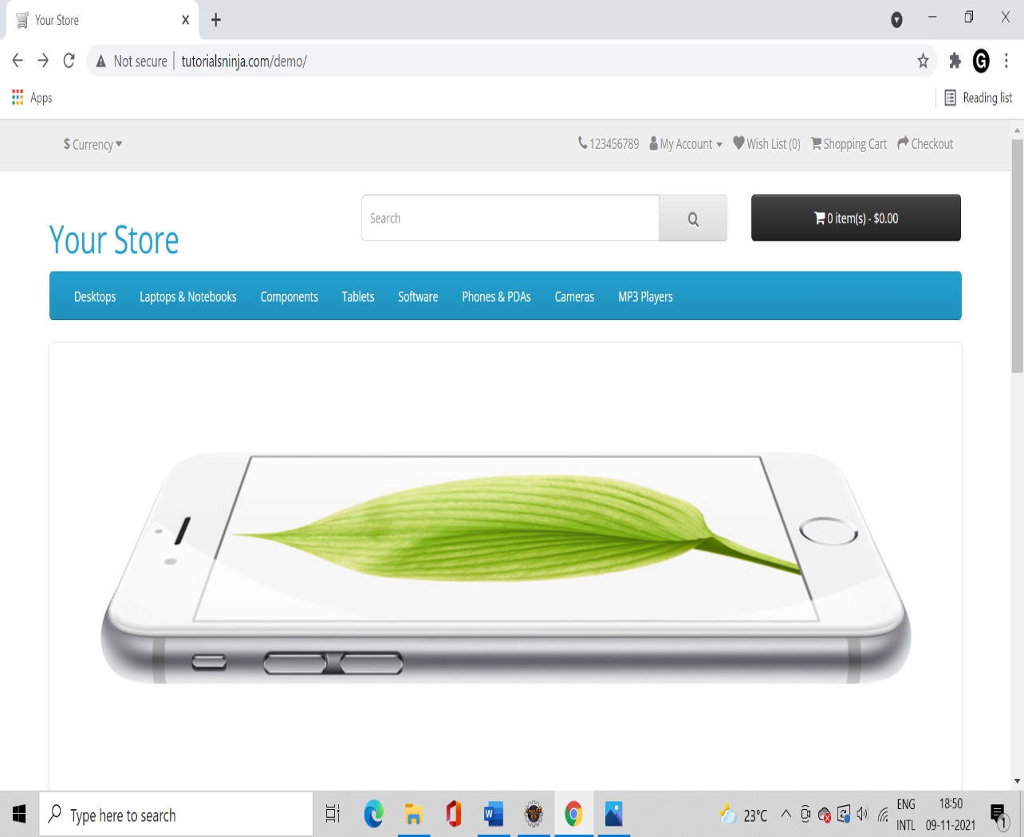

### TC_40 : To Open Tablets module

w.findElement(By.xpath("//*[@id=\"menu\"]/div[2]/ul/li[4]/a")).click();

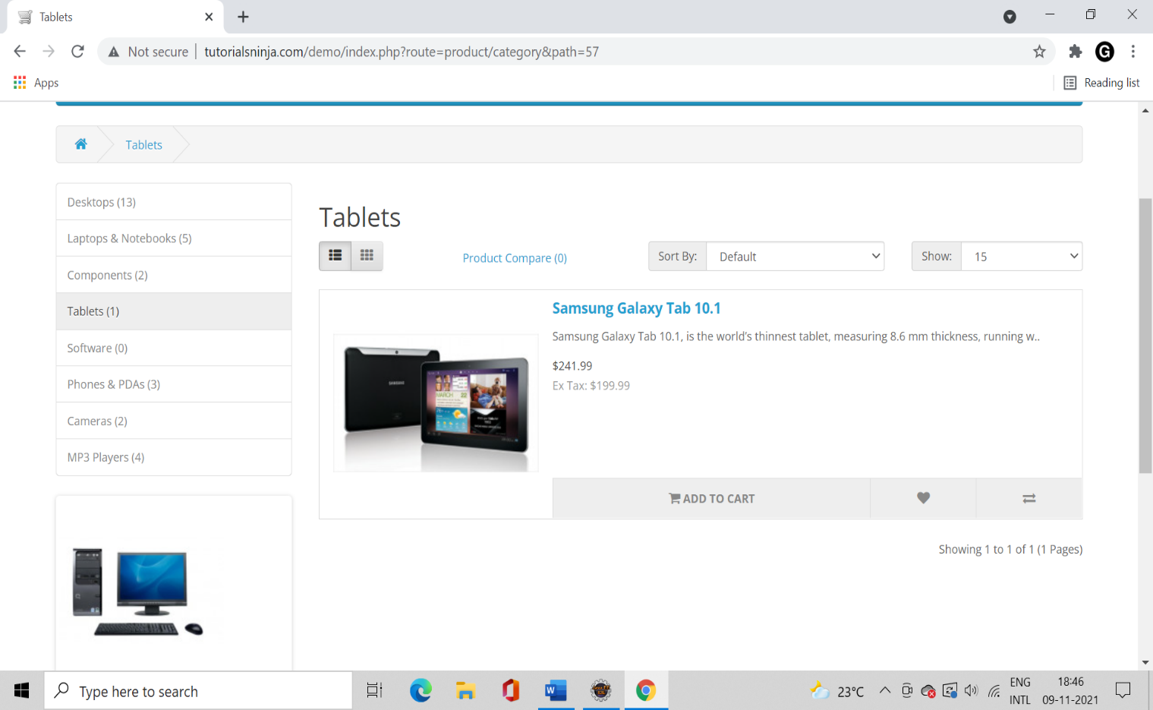

### TC_41: To Check the Functionality of List button

w.findElement(By.id("list-view")).click();

### TC_42: To Check the Functionality Sort-by Button

Select s=**new** Select(w.findElement(By.id("input-sort")));

s.selectByVisibleText("Price (High > Low)");

### TC_43: To check the functionality of Show Option and setting limit to 25

w.findElement(By.id("input-limit")).sendKeys("25");

### TC_44:To Check the functionality of link

w.findElement(By.linkText("Samsung Galaxy Tab 10.1")).click();

### TC_45: To Check the functionality of scroll up

JavascriptExecutor js=(JavascriptExecutor) w;

Thread.sleep(2000);

js.executeScript("window.scrollBy(0,2500)","");

### TC_46:To Scroll down the page

js.executeScript("window.scrollBy(0,-2500)","");

### TC_47: To check the functionality of wishlist button

w.findElement(By.xpath("//*[@id=\"content\"]/div/div[2]/div[1]/button[1]")).click();

### TC_48: To check the functionality of add quantity button

w.findElement(By.xpath("//*[@id=\"input-quantity\"]")).sendKeys("12");

### TC_49: To check the functionality of add to cart option

w.findElement(By.id("button-cart")).click();

### TC_50: To check the functionality of More button

w.findElement(By.xpath("//*[@id=\"content\"]/div/div[2]/div[3]/div/a[4]/a[2]")).click();

w.navigate().back();

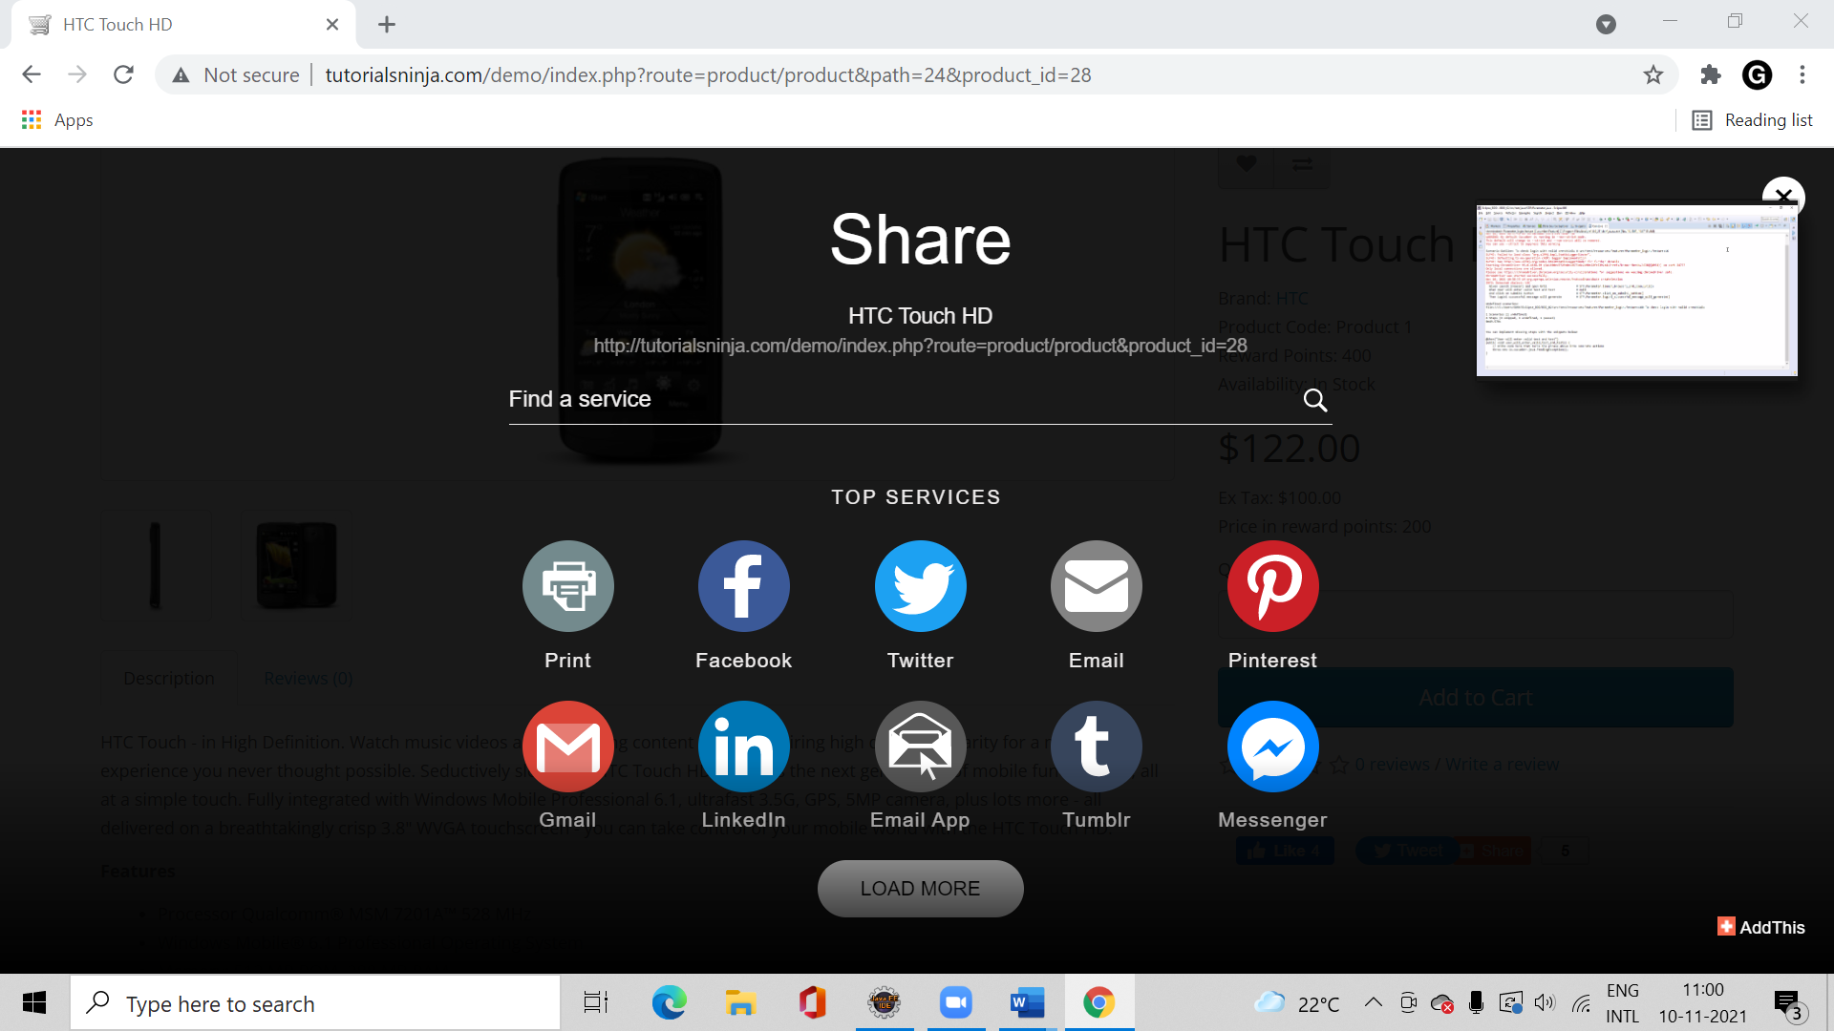

### TC_51: To open software module

w.findElement(By.linkText("Software")).click();

Thread.sleep(3000);

w.findElement(By.xpath("//*[@id=\"content\"]/div/div/a")).click();

### TC_52: To check the functionality of Macbook link

w.findElement(By.linkText("MacBook")).click();

### TC_53: To check the functionality of specification link

w.findElement(By.linkText("Specification")).click();

w.findElement(By.xpath("//*[@id=\"content\"]/div/div[1]/ul[1]/li[5]/a/img")).click();

### TC_54: To open phones&pda module

w.navigate().back();

w.findElement(By.linkText("Phones & PDAs")).click();

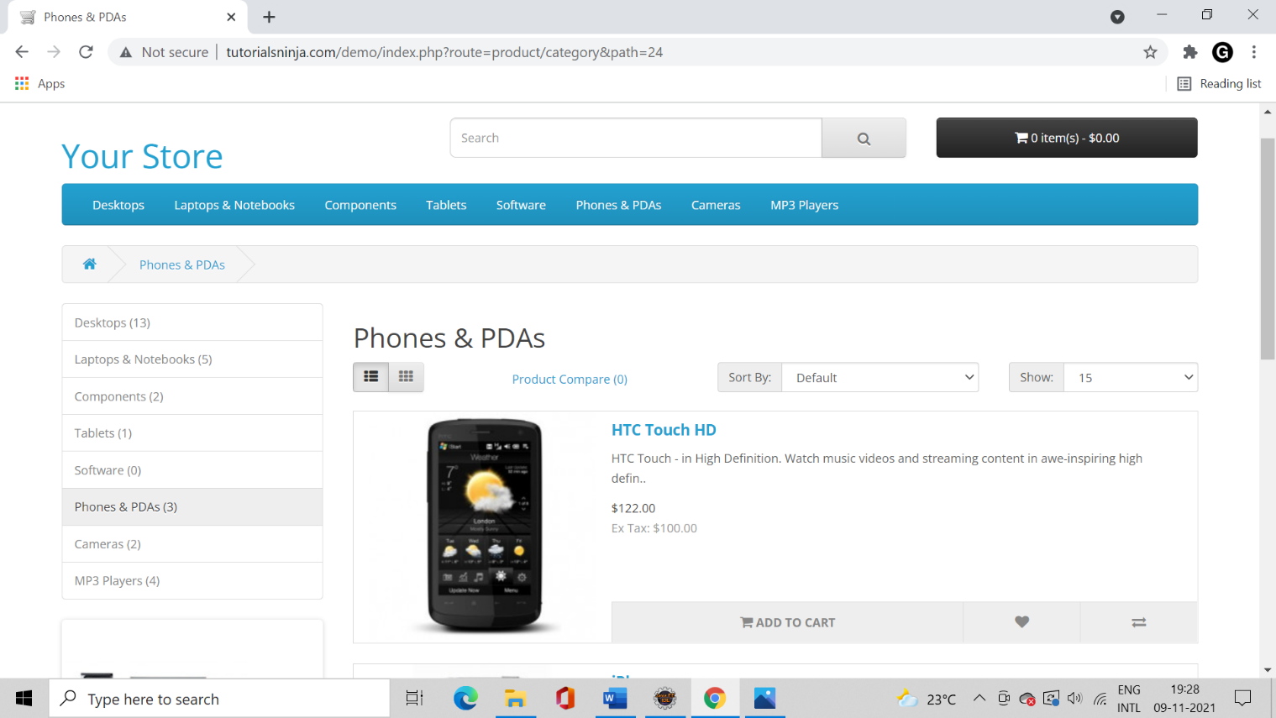

### TC_55: To check the functionality grid-view symbol

w.findElement(By.id("grid-view")).click();

w.findElement(By.linkText("HTC Touch HD")).click();

### TC_56: To check the functionality of add to cart button

w.findElement(By.id("button-cart")).click();

w.findElement(By.xpath("//*[@id=\"content\"]/div/div[2]/div[1]/button[2]")).click();

w.navigate().back();

### TC_57:To check the functionality of product compare link

w.findElement(By.id("compare-total")).click();

w.navigate().back();

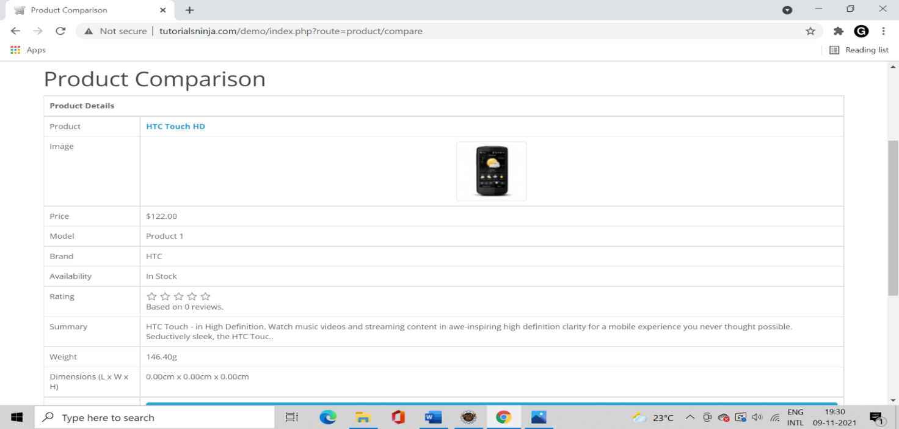

### TC_58: To Check the Functionality of palm treo pro link

w.findElement(By.linkText("Palm Treo Pro")).click();

w.findElement(By.tagName("button")).click();

w.findElement(By.name("USD")).click();

### TC_59: To check the functionality of search option

w.findElement(By.name("search")).click();

w.findElement(By.xpath("//*[@id=\"search\"]/span/button")).click();

### TC_60: To check the functionality of search criteria option

w.findElement(By.id("input-search")).sendKeys("RAM");

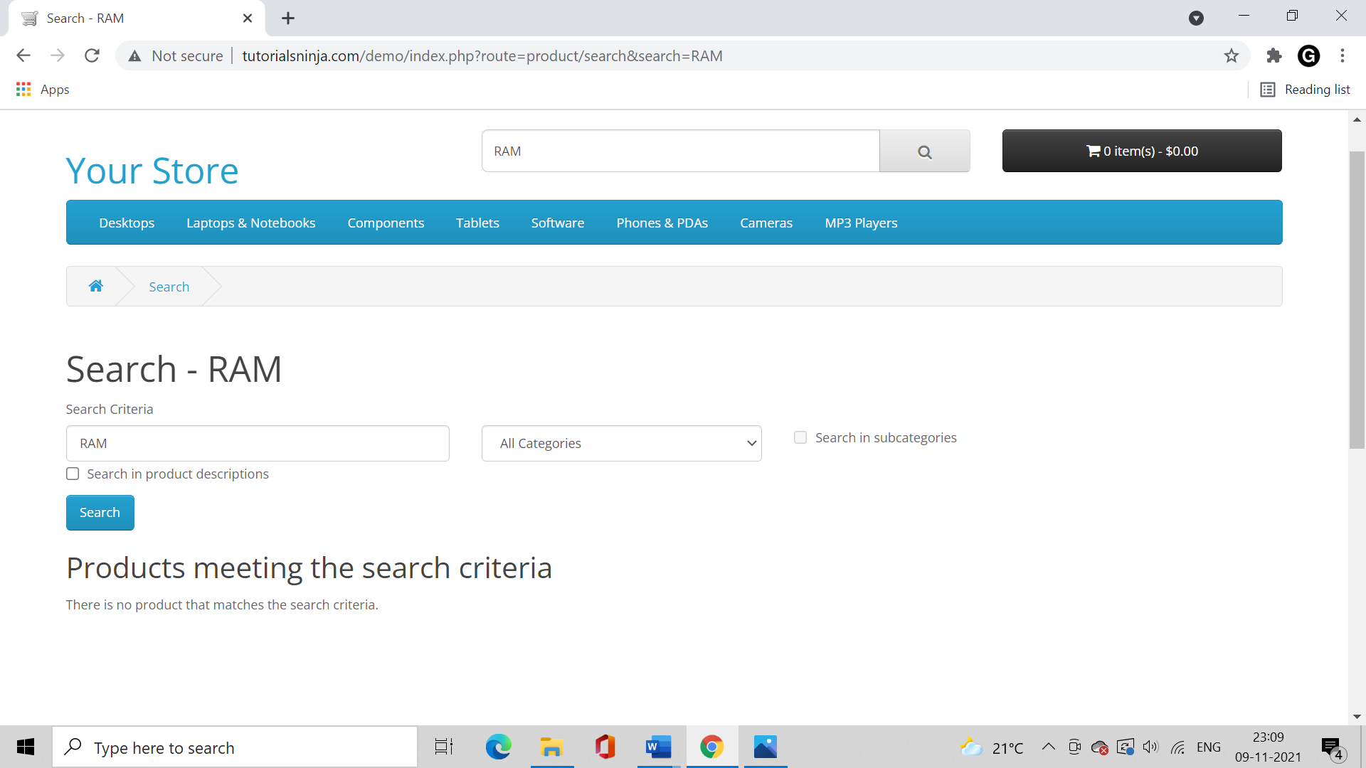

### TC_61: To Check the Functionality of drop down button

Select s1=**new** Select(w.findElement(By.tagName("select")));

s1.selectByValue("18");

w.findElement(By.name("sub_category")).click();

w.findElement(By.id("description")).click();

w.findElement(By.id("button-search")).click();

### TC_62: To Check the Functionality of Add to Cart Button

w.findElement(By.id("compare-total")).click();

### TC_63: To navigate to checkout option

w.navigate().to("http://tutorialsninja.com/demo/index.php?route=checkout/cart");

### TC_64: To Check the functionality of continue shopping option

w.findElement(By.linkText("Continue Shopping")).click();

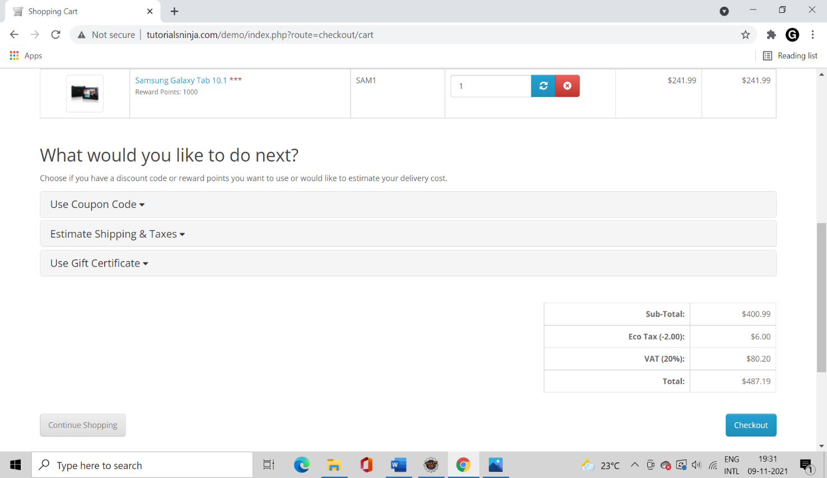

### TC_65: To add apple cinema 30 in shopping cart

w.findElement(By.linkText("Apple Cinema 30\"")).click();

w.findElement(By.xpath("//*[@id=\"content\"]/div[1]/div[2]/div[1]/button[1]")).click();

### TC_66: To check the functionality of Checkout button

w.navigate().to("http://tutorialsninja.com/demo/index.php?route=checkout/cart");

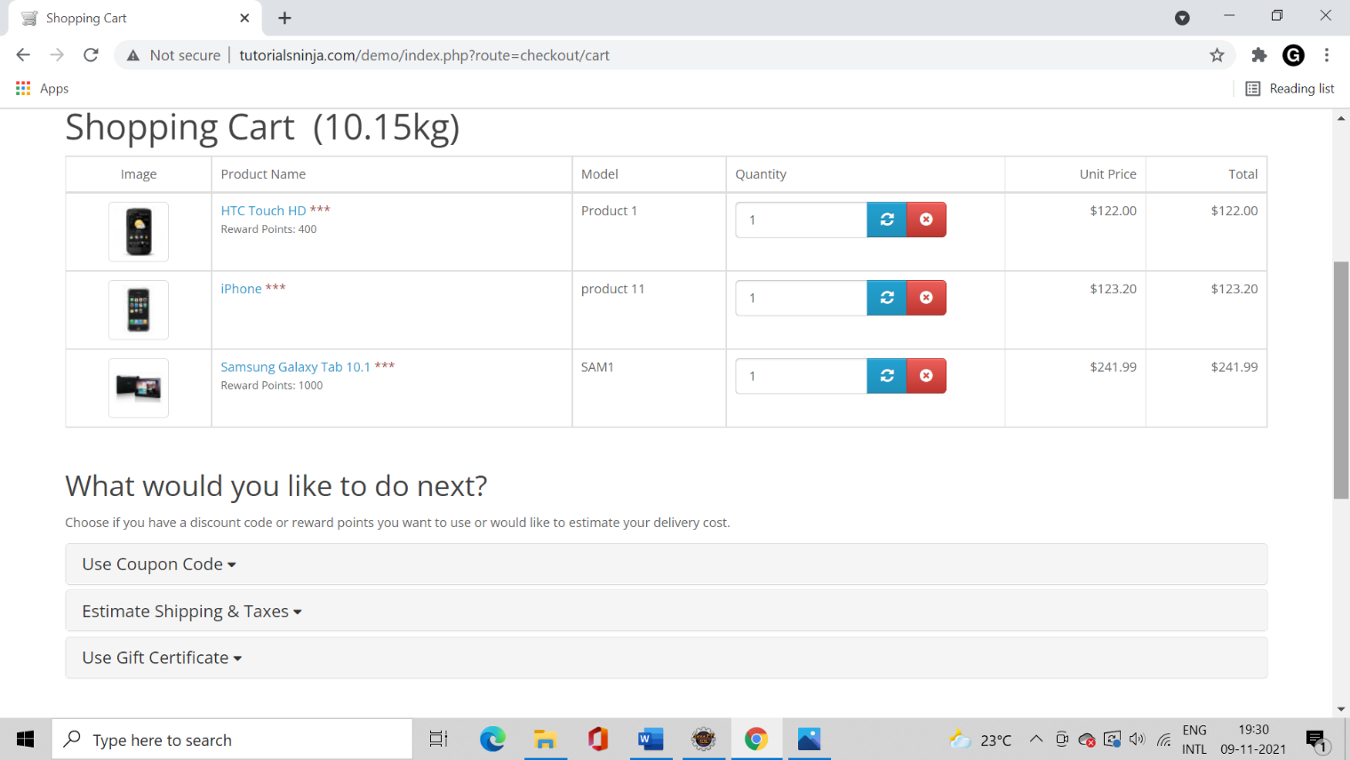

### TC_67: To check the functionality of use coupon option

w.findElement(By.partialLinkText("Use Coupon Co")).click();

w.findElement(By.name("coupon")).sendKeys("Abc45xyz");

w.findElement(By.id("button-coupon")).click();

w.navigate().refresh();

### TC_68: To check the functionality of estimate shipping taxes option

w.findElement(By.partialLinkText("Estimate Shipping &")).click();

Select s2=**new** Select(w.findElement(By.id("input-country")));

s2.selectByValue("99");

Select s3=new Select(w.findElement(By.id("input-zone")));

s3.selectByValue("1477");// for some values its showing error

w.findElement(By.id("input-postcode")).sendKeys("591106");

w.findElement(By.id("button-quote")).click();

### TC_69: To check the functionality of use gift certificate option

w.navigate().refresh();

w.findElement(By.partialLinkText("Use Gift Certifica")).click();

w.findElement(By.name("voucher")).sendKeys("ABCD2345");

w.findElement(By.id("button-voucher")).click();

### TC_70: To Check the functionality of checkout option

w.findElement(By.linkText("Checkout")).click();

w.navigate().refresh();

### TC_71: To Check the functionality of contact button

w.findElement(By.xpath("//*[@id=\"top-links\"]/ul/li[1]/a")).click();

w.findElement(By.id("input-name")).sendKeys("Pallavi");

w.findElement(By.id("input-email")).sendKeys("pallavip123@gmail.com");

w.findElement(By.id("input-enquiry")).sendKeys("there is some loading issue.please sort it out for the better performance");

w.findElement(By.xpath("//*[@id=\"content\"]/form/div/div/input")).click();

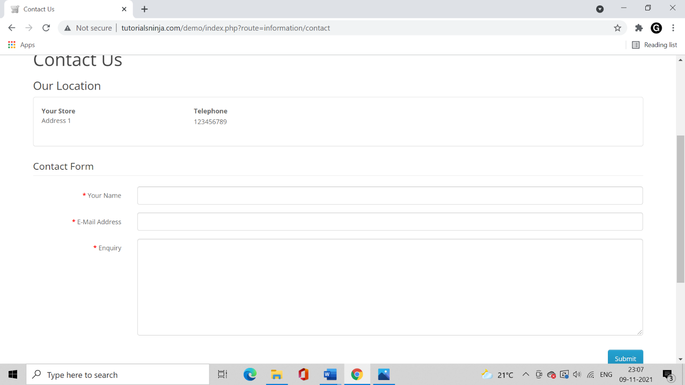

### TC_72: To check the functionality of continue button

w.findElement(By.linkText("Continue")).click();

w.navigate().refresh();

### TC_73: To check the functionality of Sides with Add to Cart Button

System.**out**.println("contact number: " +123456789);

### TC_74: To check the functionality of add to cart symbol

w.findElement(By.xpath("//*[@id=\"cart-total\"]")).click();

w.findElement(By.xpath("//*[@id=\"cart\"]/ul/li[2]/div/p/a[1]")).click();

w.navigate().back();

### TC_75: To remove 1 product from cart

w.findElement(By.xpath("//*[@id=\"cart-total\"]")).click();

w.findElement(By.xpath("//*[@id=\"cart\"]/ul/li[1]/table/tbody/tr/td[5]/button")).click();

### TC_76: To print name of the current page

System.**out**.println("Title name: "+ w.getTitle());

### TC_77: Launch the browser and open” tuturialsninja” demo Website.

System.Setproperty("Webdriver.Chrome.Driver", "C:\\Users\\Ratnakar\\Desktop\\Chromedriver.Exe");

Webdriver W=**New** Chromedriver();

W.Get("Http://Tutorialsninja.Com/Demo/");

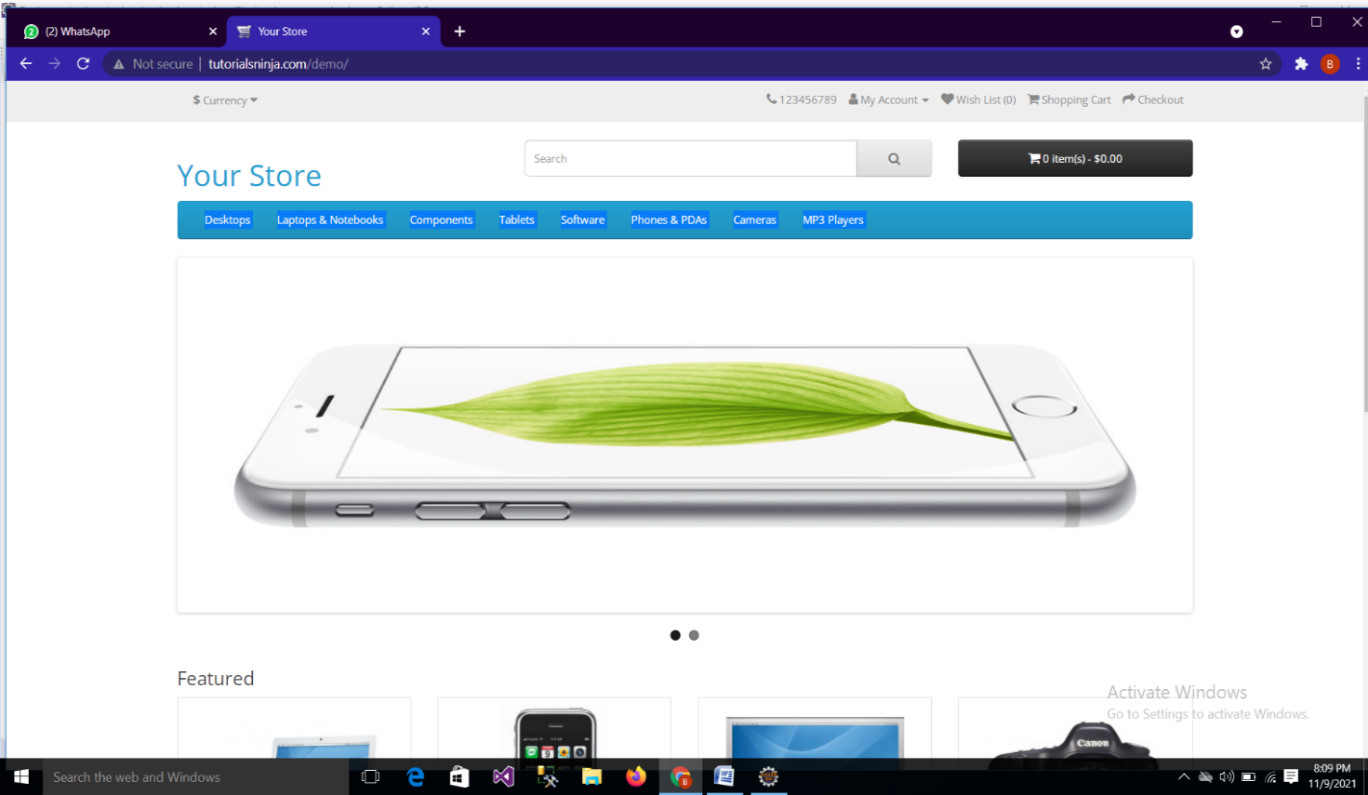

### TC_78:To check the Functionality of My Account option

w.findElement(By.linkText("My Account")).click();

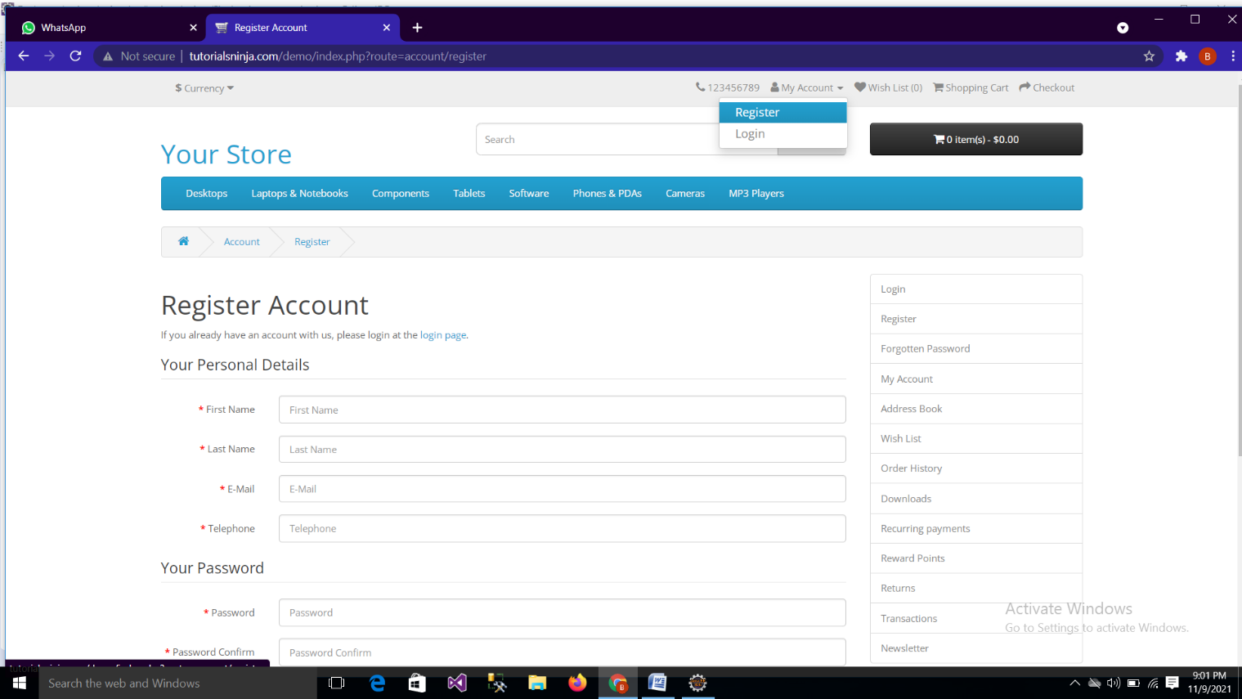

### TC_79: To Check the Functionality of Register option

w.findElement(By.linkText("Register")).click();

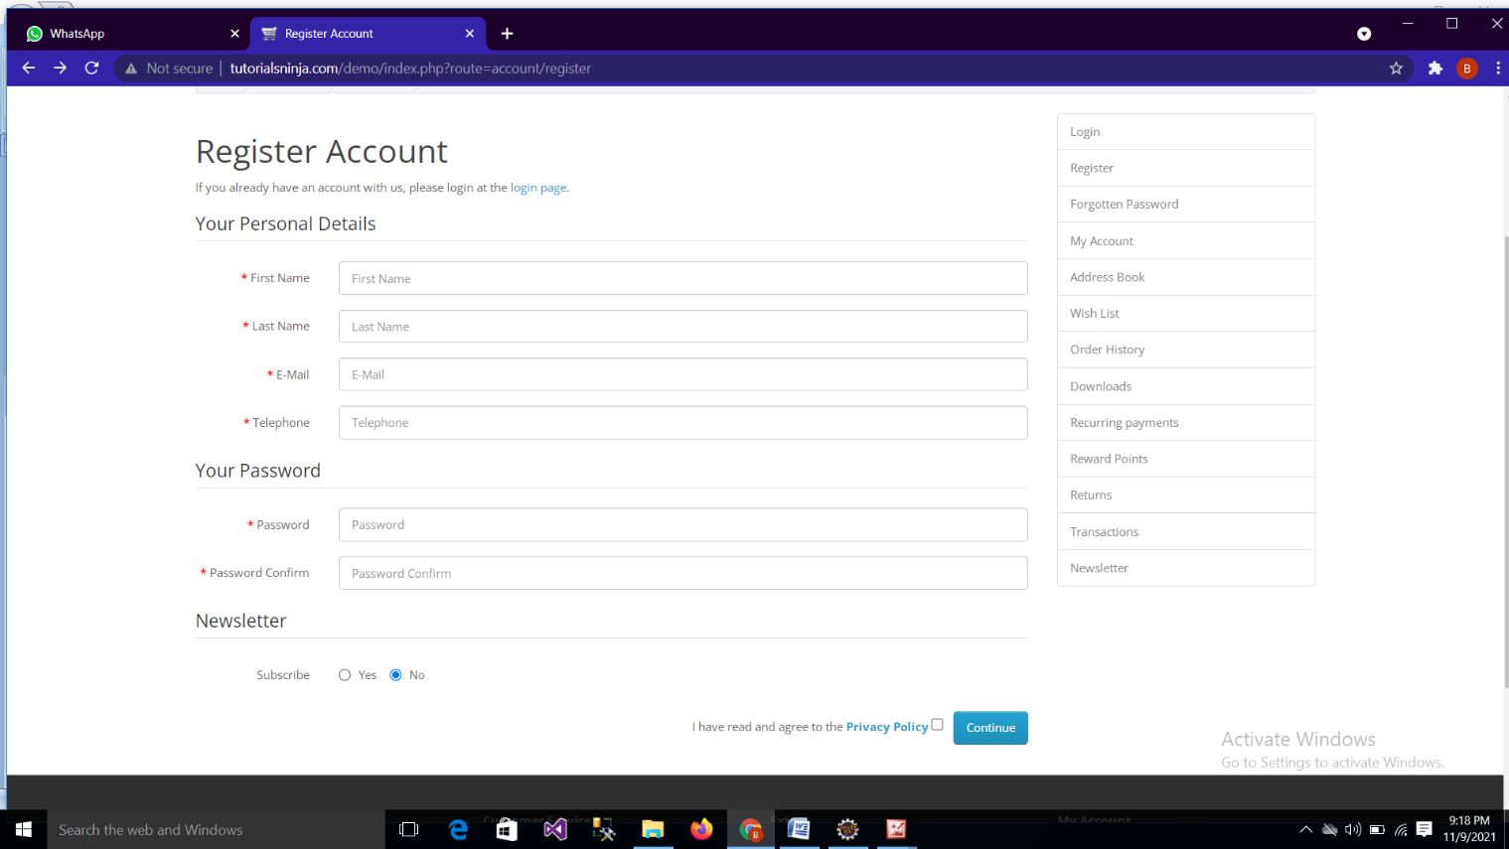

### TC_80:To Check the Functionality of Continue button

w.findElement(By.id("input-firstname")).sendKeys("bhagyashri");

w.findElement(By.id("input-lastname")).sendKeys("Dige");

w.findElement(By.id("input-email")).sendKeys("bhagyashridige11@gmail.com");

w.findElement(By.id("input-telephone")).sendKeys("9921579674");

w.findElement(By.id("input-password")).sendKeys("BSD30111997@dige");

w.findElement(By.id("input-confirm")).sendKeys("BSD30111997@dige");

w.findElement( By.name("newsletter")).click();

w.findElement(By.name("agree")).click();

w.findElement(By.xpath("//body/div[@id='account-register']/div[1]/div[1]/form[1]/div[1]/div[1]/input[2]")).click();

w.navigate().to("http://tutorialsninja.com/demo/index.php?route=account/register");

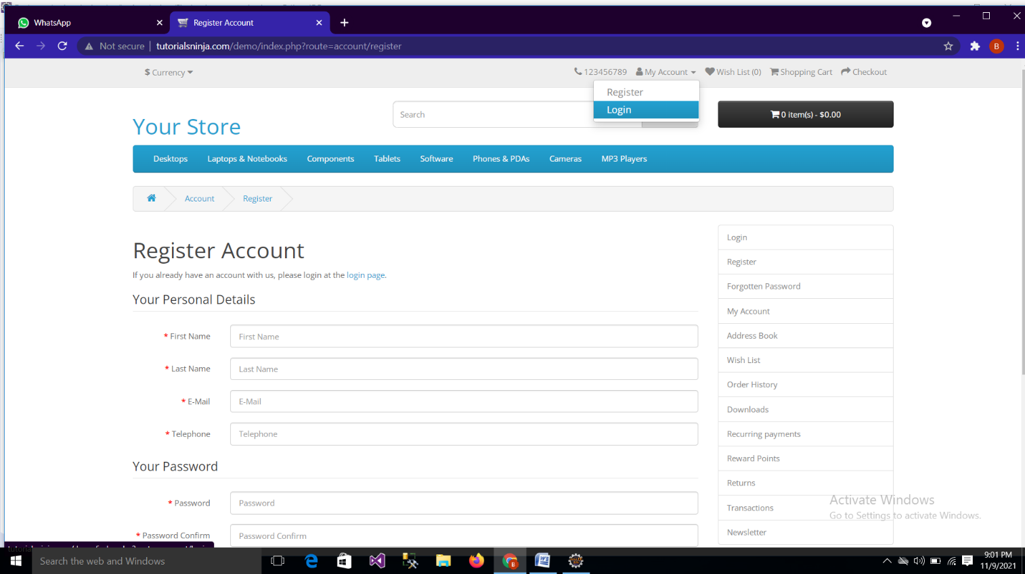

### TC_81: To check the Functionality of My account Button

w.navigate().to("http://tutorialsninja.com/demo/index.php?route=account/register");

w.findElement(By.linkText("My Account")).click();

w.navigate().back();

### Screenshot (78).png

### TC_82: To Check the Functionality of Edit account Button

w.navigate().to("http://tutorialsninja.com/demo/index.php?route=account/register");

w.findElement(By.linkText("Edit Account")).click();

w.findElement(By.linkText("Back")).click();

w.findElement(By.xpath("//body/div[@id='account-edit']/div[1]/div[1]/form[1]/div[1]/div[2]/input[1]")).click();

w.navigate().back();

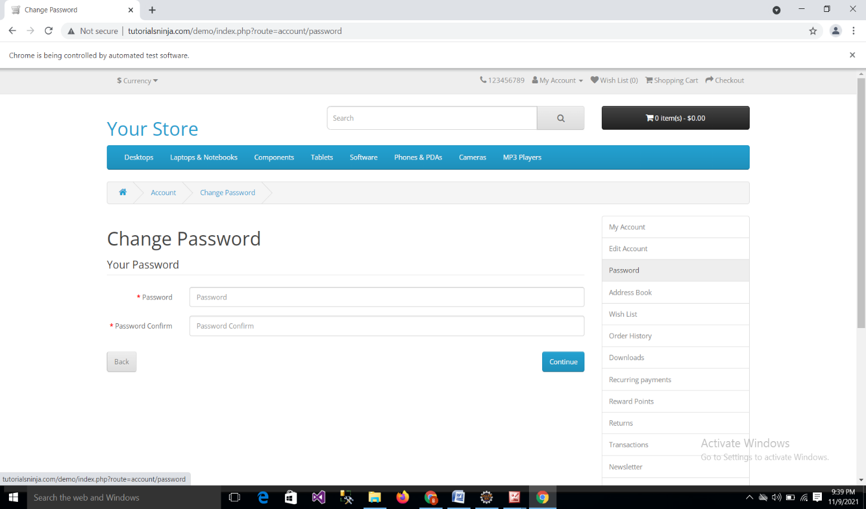

### TC_83: To Check the Functionality Password Button

w.navigate().to("http://tutorialsninja.com/demo/index.php?route=account/register");

w.findElement(By.linkText("Password")).click();

w.findElement(By.id("input-password")).sendKeys("BSD30111997@dige");

w.findElement(By.id("input-confirm")).sendKeys("BSD30111997@dige");

w.findElement(By.xpath("//body/div[@id='account-password']/div[1]/div[1]/form[1]/div[1]/div[2]/input[1]")).click();

w.navigate().back();

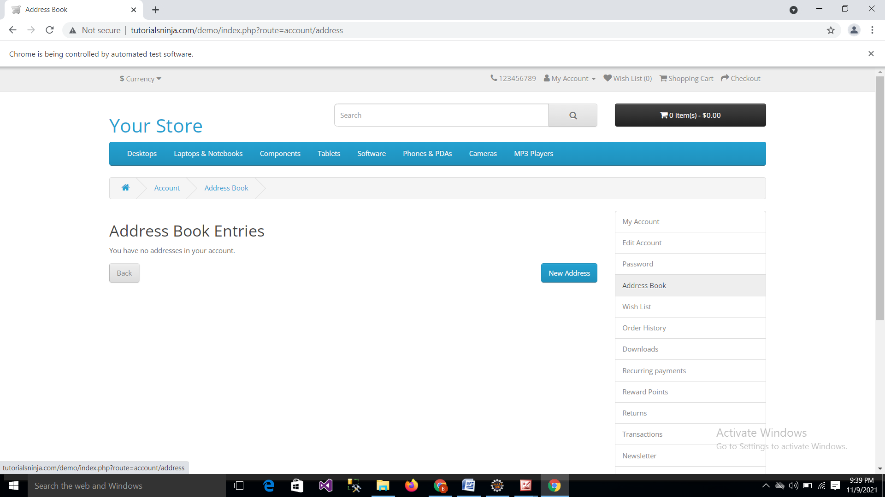

### TC_84: To check the Functionality of Address Book Button

w.navigate().to("http://tutorialsninja.com/demo/index.php?route=account/register");

w.findElement(By.linkText("Address Book")).click();

w.findElement(By.linkText("Back")).click();

w.findElement(By.linkText("New Address")).click();

w.navigate().back();

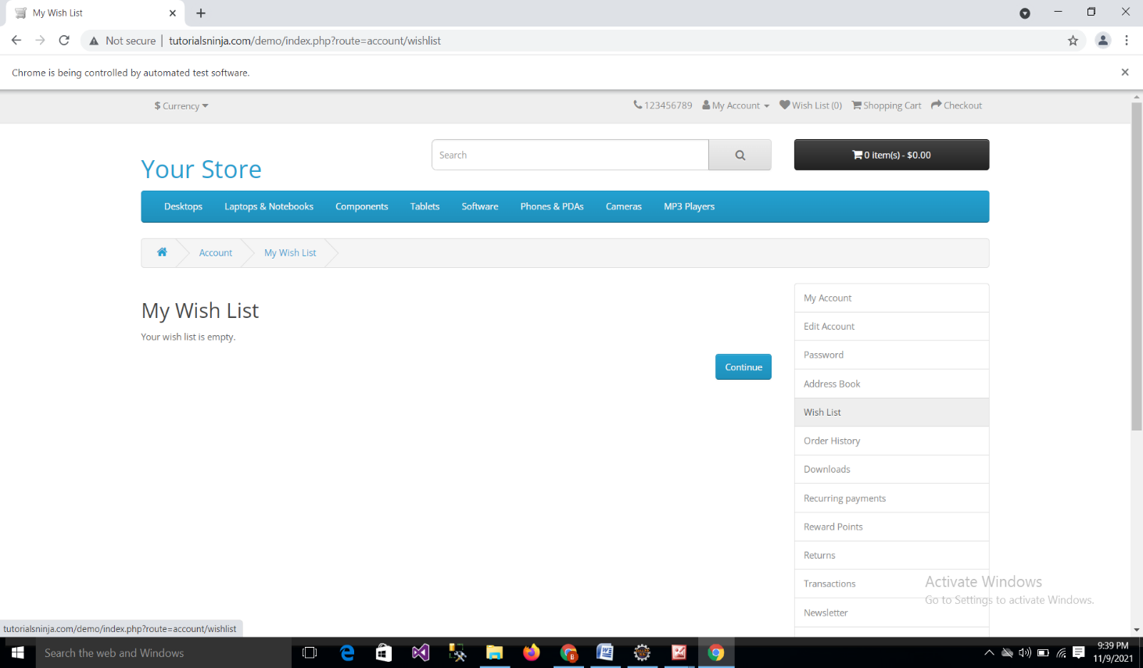

### TC_85:To check the Functionality of Wish List Button

w.navigate().to("http://tutorialsninja.com/demo/index.php?route=account/register");

w.findElement(By.linkText("Wish List")).click();

w.findElement(By.linkText("Continue")).click();

w.findElement(By.linkText("Back")).click();

w.navigate().back();

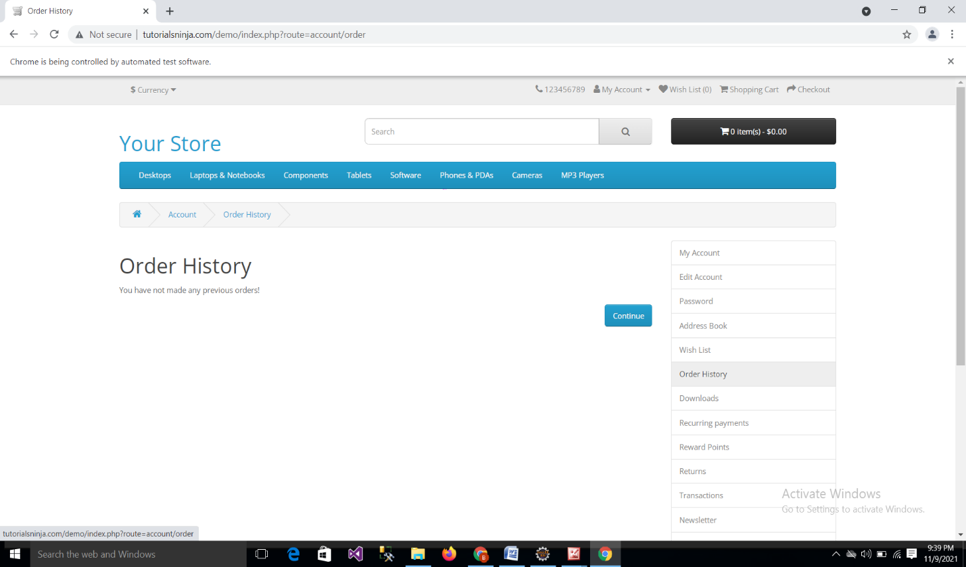

### TC_86: To check the Functionality of Order History Button

w.navigate().to("http://tutorialsninja.com/demo/index.php?route=account/register");

w.findElement(By.linkText("Order History")).click();

w.findElement(By.linkText("Continue")).click();

w.findElement(By.linkText("Back")).click();

w.navigate().back();

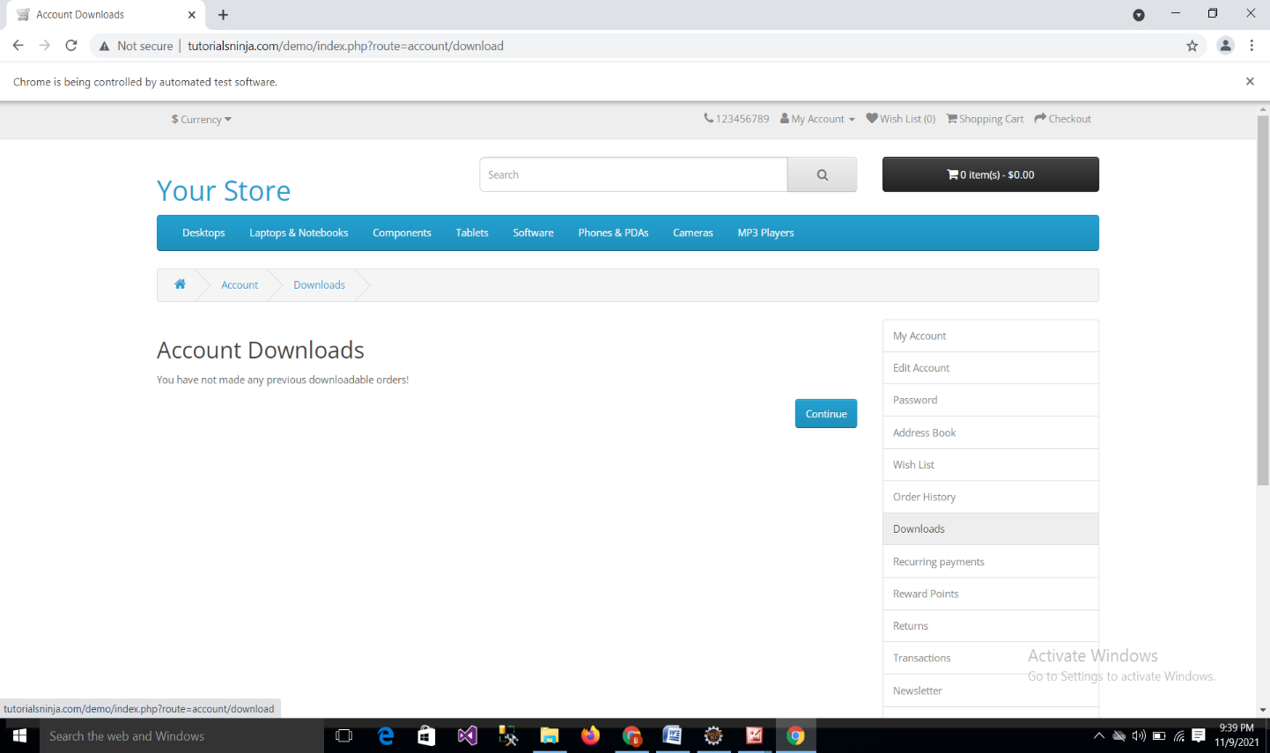

### TC_87: To check the Functionality of Downloads Button

w.navigate().to("http://tutorialsninja.com/demo/index.php?route=account/register");

w.findElement(By.linkText("Downloads")).click();

w.findElement(By.linkText("Continue")).click();

w.navigate().back();

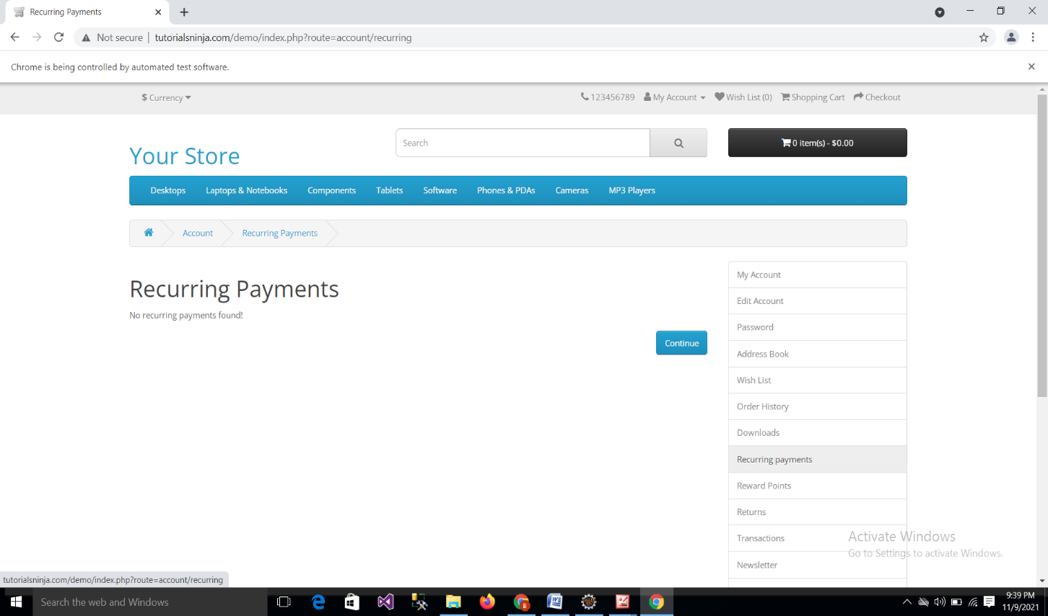

### TC_88: To check the Functionality of Reccuring payment Button

w.navigate().to("http://tutorialsninja.com/demo/index.php?route=account/register");

w.findElement(By.linkText("Recurring payments")).click();

w.findElement(By.linkText("Continue")).click();

w.navigate().back();

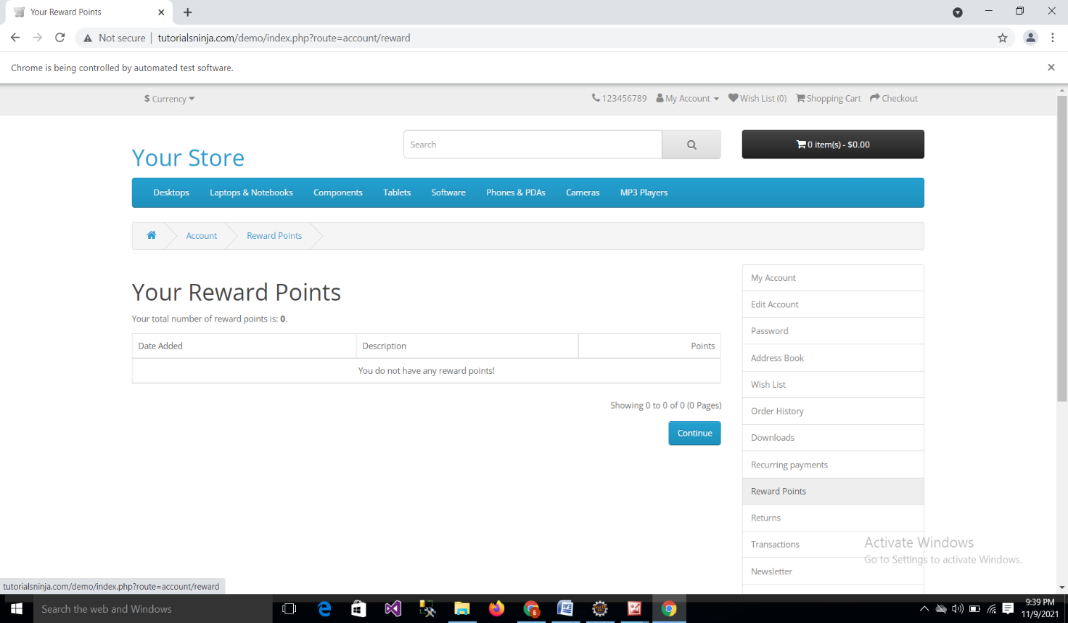

### TC_89: To check the Functionality of Reward Points Button

w.navigate().to("http://tutorialsninja.com/demo/index.php?route=account/register");

w.findElement(By.linkText("Reward Points")).click();

w.findElement(By.linkText("Continue")).click();

w.navigate().back();

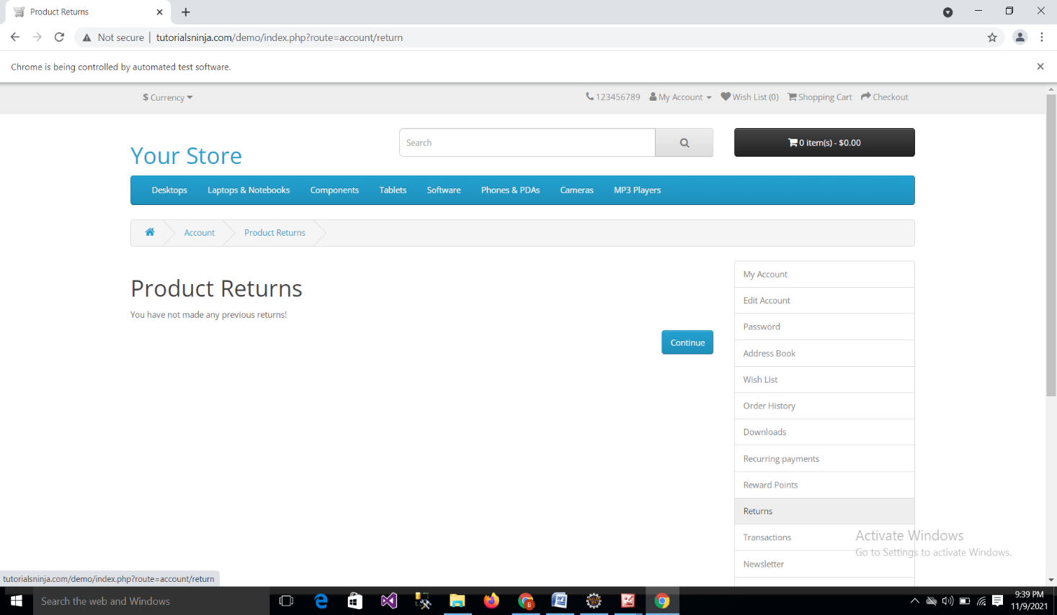

### TC_90: To check the Functionality of Return Button

w.navigate().to("http://tutorialsninja.com/demo/index.php?route=account/register");

w.findElement(By.linkText("Returns")).click();

w.findElement(By.linkText("Continue")).click();

w.navigate().back();

### Screenshot (87).png

### 

### TC_91:To check the Functionality of Transaction Button

w.navigate().to("http://tutorialsninja.com/demo/index.php?route=account/register");

w.findElement(By.linkText("Transactions")).click();

w.findElement(By.linkText("Continue")).click();

w.navigate().back();

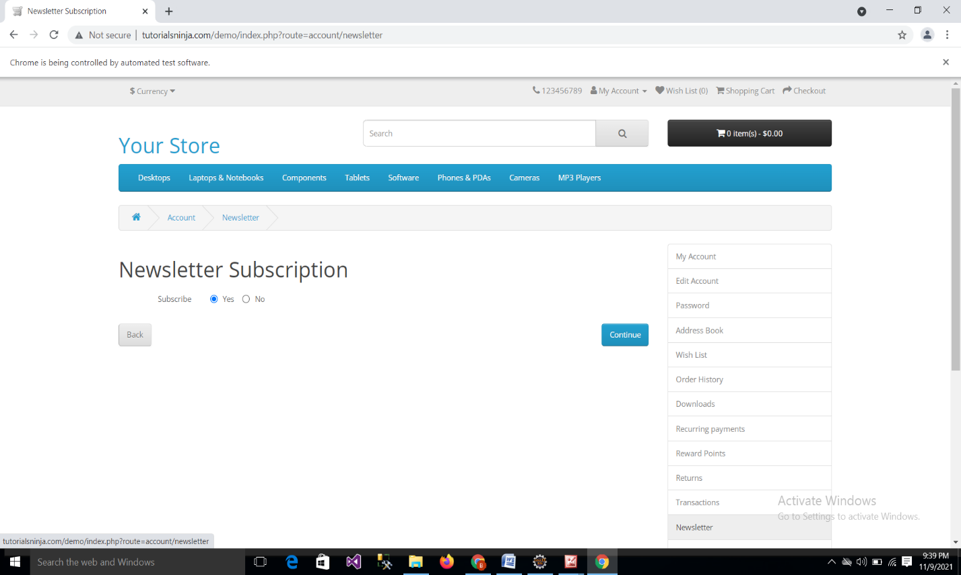

### TC_92: To check the Functionality of Newsletter Button.

w.navigate().to("http://tutorialsninja.com/demo/index.php?route=account/register");

w.findElement(By.linkText("Newsletter")).click();

w.navigate().to("http://tutorialsninja.com/demo/index.php?route=account/newsletter");

w.findElement(By.xpath("//body/div[@id='account-newsletter']/div[1]/div[1]/form[1]/div[1]/div[2]/input[1]")).click();

w.navigate().to("http://tutorialsninja.com/demo/index.php?route=account/register");

w.navigate().back();

### TC_93:To check the Functionality of Contact us Button

w.navigate().to("http://tutorialsninja.com/demo/index.php?route=account/register");

w.findElement(By.linkText("Contact Us")).click();

w.findElement(By.id("input-enquiry")).sendKeys("To check contact");

### TC_94: To check the Functionality of MP3 Player Button

w.navigate().to("http://tutorialsninja.com/demo/index.php?route=account/register");

w.findElement(By.linkText("MP3 Players")).click();

### TC_95: To check the Functionality of MP3 Player Button with “test 11(0) Option

w.findElement(By.linkText("test 11 (0)")).click();

w.findElement(By.linkText("Continue")).click();

### TC_96:To Check the Functionality of MP3 Player Button with “test 12(0) Option

w.navigate().to("http://tutorialsninja.com/demo/index.php?route=account/register");

w.findElement(By.linkText("MP3 Players")).click();

w.findElement(By.linkText("test 12 (0)")).click();

w.findElement(By.linkText("Continue")).click();

### TC_97:-To check the Functionality of MP3 Player Button with “test 15(0) Option

w.navigate().to("http://tutorialsninja.com/demo/index.php?route=account/register");

w.findElement(By.linkText("MP3 Players")).click();

w.findElement(By.linkText("test 15(0)")).click();

w.findElement(By.linkText("Continue")).click();

### TC_98: To check the Functionality of MP3 Player Button with “test 16(0) Option

w.navigate().to("http://tutorialsninja.com/demo/index.php?route=account/register");

w.findElement(By.linkText("MP3 Players")).click();

w.findElement(By.linkText("test 16 (0)")).click();

w.findElement(By.linkText("Continue")).click();

### TC_99: To Check the Functionality of MP3 Player Button with “test 17(0) Option

w.navigate().to("http://tutorialsninja.com/demo/index.php?route=account/register");

w.findElement(By.linkText("MP3 Players")).click();

w.findElement(By.linkText("test 17 (0)")).click();

w.findElement(By.linkText("Continue")).click();

### TC_100: To check the Functionality of MP3 Player Button with “test 18(0) Option

w.navigate().to("http://tutorialsninja.com/demo/index.php?route=account/register");

w.findElement(By.linkText("MP3 Players")).click();

w.findElement(By.linkText("test 18 (0)")).click();

w.findElement(By.linkText("Continue")).click();

### TC_101:To check the Functionality of MP3 Player Button with “test 19(0) Option

w.navigate().to("http://tutorialsninja.com/demo/index.php?route=account/register");

w.findElement(By.linkText("MP3 Players")).click();

w.findElement(By.linkText("test 19 (0)")).click();

w.findElement(By.linkText("Continue")).click();

### TC_102: To Check the Functionality of MP3 Player Button with “test 20(0) Option

w.navigate().to("http://tutorialsninja.com/demo/index.php?route=account/register");

w.findElement(By.linkText("MP3 Players")).click();

w.findElement(By.linkText("test 20 (0)")).click();

w.findElement(By.linkText("Continue")).click();

### TC_103:To check the Functionality of MP3 Player Button with “test 21(0) Option

w.navigate().to("http://tutorialsninja.com/demo/index.php?route=account/register");

w.findElement(By.linkText("MP3 Players")).click();

w.findElement(By.linkText("test 21 (0)")).click();

w.findElement(By.linkText("Continue")).click();

### TC_104:To check the Functionality of MP3 Player Button with “test 22(0) Option

w.navigate().to("http://tutorialsninja.com/demo/index.php?route=account/register");

w.findElement(By.linkText("MP3 Players")).click();

w.findElement(By.linkText("test 22 (0)")).click();

w.findElement(By.linkText("Continue")).click();

### TC_105: To check the Functionality of MP3 Player Button with “test 23(0) Option

w.navigate().to("http://tutorialsninja.com/demo/index.php?route=account/register");

w.findElement(By.linkText("MP3 Players")).click();

w.findElement(By.linkText("test 23(0)")).click();

w.findElement(By.linkText("Continue")).click();

### TC_106:To check the Functionality of MP3 Player Button with “test 24(0) Option

w.navigate().to("http://tutorialsninja.com/demo/index.php?rute=account/register");

w.findElement(By.linkText("MP3 Players")).click();

w.findElement(By.linkText("test 24 (0)")).click();

w.findElement(By.linkText("Continue")).click();

### TC_107:To Check the Functionality of MP3 Player Button with “test 4(0) Option

w.navigate().to("http://tutorialsninja.com/demo/index.php?route=account/register");

w.findElement(By.linkText("MP3 Players")).click();

w.findElement(By.linkText("test 4 (0)")).click();

w.findElement(By.linkText("Continue")).click();

### TC_108: To check the Functionality of MP3 Player Button with “test 5(0) Option

w.navigate().to("http://tutorialsninja.com/demo/index.php?route=account/register");

w.findElement(By.linkText("MP3 Players")).click();

w.findElement(By.linkText("test 5 (0)")).click();

w.findElement(By.linkText("Continue")).click();

### TC_109:To check the Functionality of MP3 Player Button with “test 6(0) Option

w.navigate().to("http://tutorialsninja.com/demo/index.php?route=account/register");

w.findElement(By.linkText("MP3 Players")).click();

w.findElement(By.linkText("test 6 (0)")).click();

w.findElement(By.linkText("Continue")).click();

### TC_110: To check the Functionality of MP3 Player Button with “test 7(0) Option

w.navigate().to("http://tutorialsninja.com/demo/index.php?route=account/register");

w.findElement(By.linkText("MP3 Players")).click();

w.findElement(By.linkText("test 7 (0)")).click();

w.findElement(By.linkText("Continue")).click();

### TC_111: To check the Functionality of MP3 Player Button with “test 8(0) Option

w.navigate().to("http://tutorialsninja.com/demo/index.php?route=account/register");

w.findElement(By.linkText("MP3 Players")).click();

w.findElement(By.linkText("test 8 (0)")).click();

w.findElement(By.linkText("Continue")).click();

### TC_112: To Check the Functionality of MP3 Player Button with “test 9(0) Option

w.navigate().to("http://tutorialsninja.com/demo/index.php?route=account/register");

w.findElement(By.linkText("MP3 Players")).click();

w.findElement(By.linkText("test 9 (0)")).click();

w.findElement(By.linkText("Continue")).click();

### TC_113: To check the Functionality of Camera Button

w.navigate().to("http://tutorialsninja.com/demo/index.php?route=account/register");

w.findElement(By.linkText("Cameras")).click();

w.findElement(By.xpath("//body/div[@id='information-contact']/div[1]/div[1]/form[1]/div[1]/div[1]/input[1]")).click();

### DEFECT REPORT

Defect ID D01

Reporting Date 11/11/2021

Project Name Tutorials Ninja

Module Name Tablets

Type of Defect Functional

Phase Testing

Summary Quantity Text Field Taking Wrong quantity number

Description Expected quantity: 2 Actual quantity:12

Severity High

Priority High

Status Opened

Reported By Gaytri Pejolli

Reported To Bhagyshree Dige

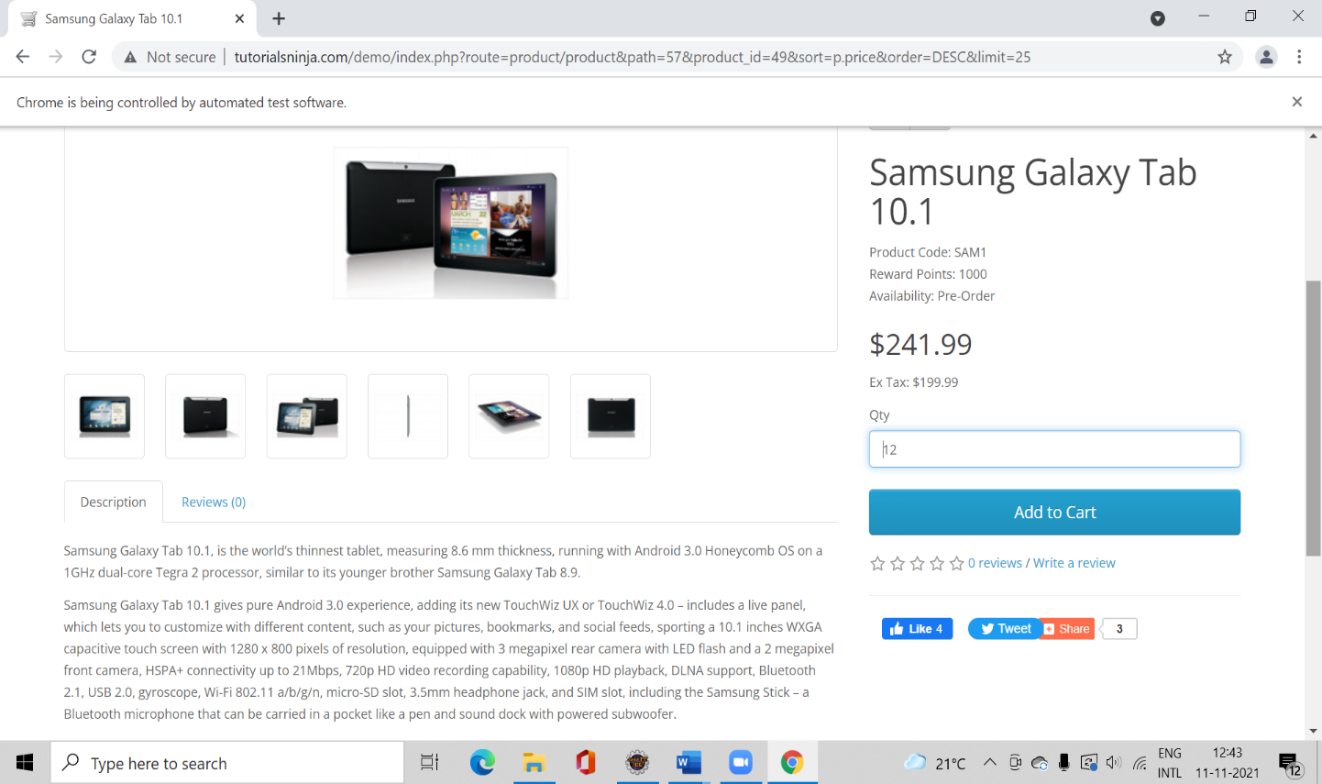

### 

### 

Defect ID D02

Reporting Date 11/11/2021

Project Name Tutorials Ninja

Module Name DeskTop

Type of Defect Functional

Phase Testing

Summary Continue Button redirect to home page

Description Expected Result Continue button should display no product

message when clicking.

Actual Result Continue button redirect to home page.

Severity High

Priority High

Status Opened

Reported By Dipali Shinde

Reported To Bhagyshree Dige

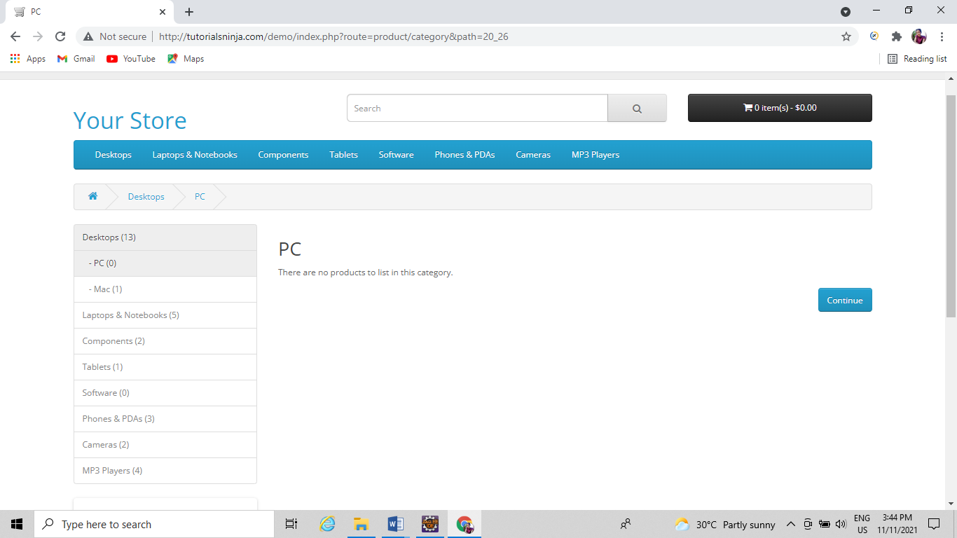

Defect ID D03

Reporting Date 11/11/2021

Project Name Tutorials Ninja

Module Name Desktop(iMac)

Type of Defect Functional

Phase Testing

Summary Quantity Text Field Taking Wrong quantity number Description Expected quantity: 5 Actual quantity:15

Severity High

Priority High

Status Opened

Reported By Dipali Shinde

Reported To Bhagyashree dige

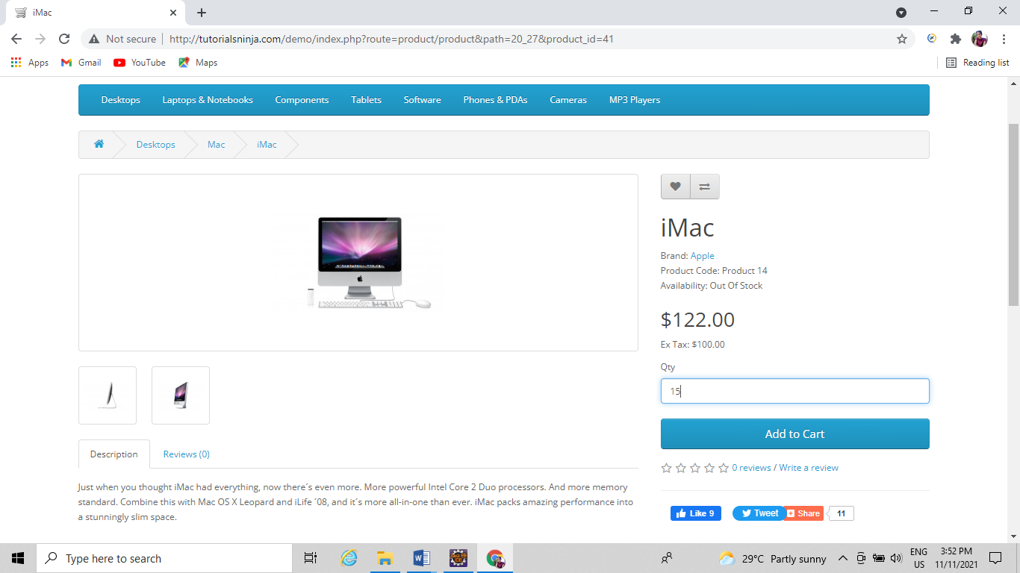

Defect ID D04

Reporting Date 11/11/2021

Project Name Tutorials Ninja

Module Name Desktop(iMac)

Type of Defect Functional

Phase Testing

Summary Review Button in imac option is not working

Description Review Button in imac option is not working sometimes

Severity High

Priority High

Status Opened

Reported By Dipali Shinde

Reported To Bhagyashree dige

